## **🧠 MASTER NOTES: Agentic AI — Full Training Walkthrough (**

### **🎯 SESSION GOAL:**

By the end of the session, Learners should:

* Understand what Agentic AI is and how it’s different from regular AI.
* Know where and how it fits in a modern tech stack.
* See two **real demo agents** and understand how to build one.
* Be aware of trade-offs, tools, frameworks, and ethical considerations.

## **🧭 SECTION 1: BEFORE AGENTS — The Old AI Way**

### **🧩 What We Had Before**

* ChatGPT-style assistants that are **stateless**, **predictive**, **reactive**.
* Prompt in → Output out. No planning, no memory, no autonomy.
* Example:  
    
    
   User: "Summarize this article."  
   LLM: (Does it, but doesn't store info or do any next steps)

### **❌ Limitations:**

* No long-term memory
* No ability to take *real-world actions* (like calling APIs, browsing, filing reports)
* No workflows, no multi-step goals

## **🤖 SECTION 2: WHAT IS AGENTIC AI?**

### **✅ Definition:**

Agentic AI refers to AI systems that can **autonomously plan, decide, and act** using tools, memory, and reasoning — much like a human assistant.

### **🧠 Core Ingredients of an AI Agent:**

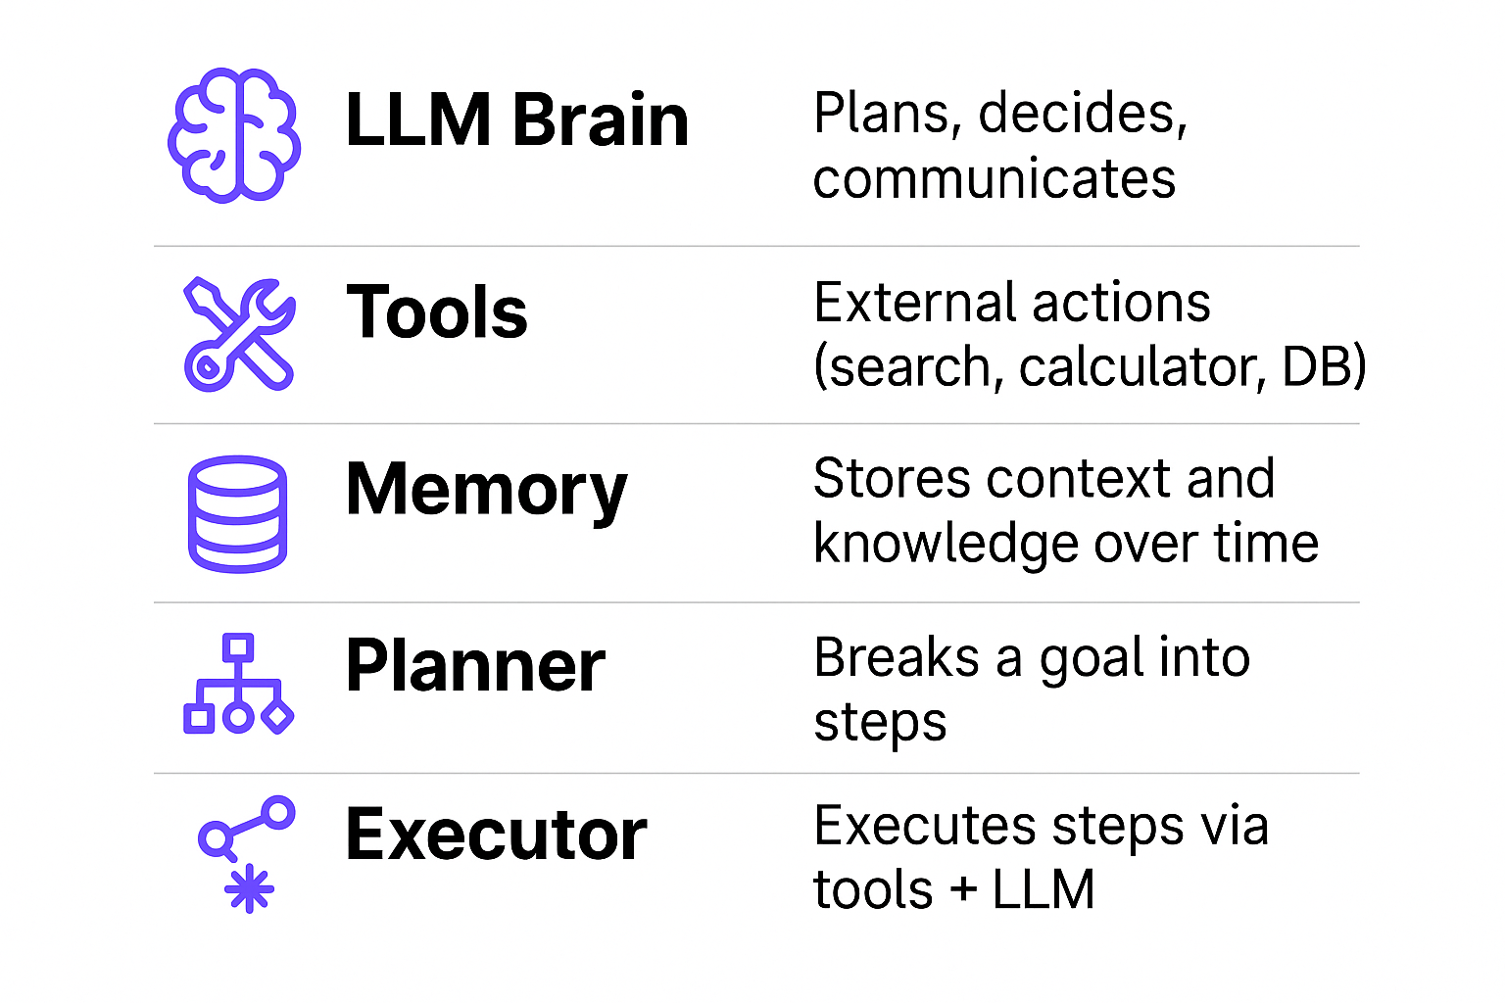

### **✨ Simple Analogy:**

ChatGPT is like a smart parrot.  
 An AI Agent is like a smart **intern** — who thinks, searches, reads docs, and writes back a report.

## **🔍 SECTION 3: WHY AGENTS?**

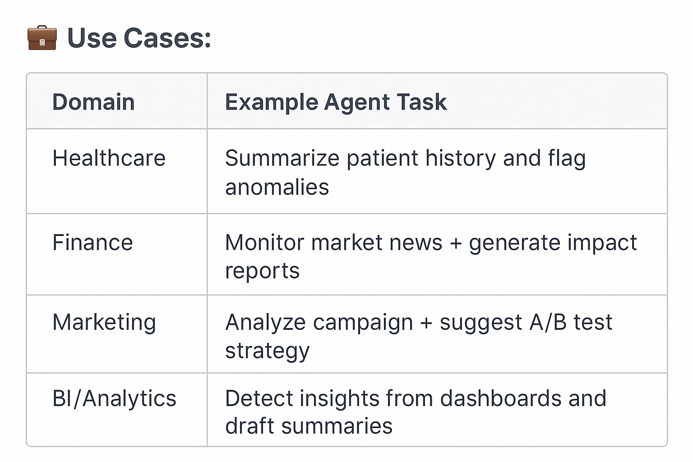

### **🎯 Agents Are Ideal When:**

* You need **multi-step reasoning**
* You want to use **external tools**
* You want **autonomy** and **goal-orientation**

## **🏗️ SECTION 4: AGENTIC ARCHITECTURE**

**Understanding the moving parts of an Agentic AI System**

Agentic systems are **modular**. Each part is responsible for a specific job: understanding prompts, planning what to do, acting via tools, remembering context, and stitching it all together.  
 Let’s explore the **5 essential layers** in a real-world agentic AI system.

### **🧱 1. Interface Layer**

**Where the user interacts with the agent.** Can be a chatbot UI, API endpoint, voice assistant, or even a CLI.

#### **🔹 Purpose:**

* Accepts input in natural language
* Returns output from the agent
* Handles retries, logging, user identity, etc.

#### **🔹 Common Implementations:**

* **Web frontends**: Streamlit, React, Gradio
* **Chat APIs**: Twilio, Slack, WhatsApp bots
* **Webhooks / REST APIs** for programmatic calls

#### **🔹 Example:**

A user types into a hospital chatbot:

“Can you summarize this patient's medication history and recommend changes?”

The interface forwards the request to the Agent Brain.

### **🧠 2. Agent Brain Layer**

**The decision-maker. This is where your LLM lives.**

This layer interprets user intent, plans next actions, selects tools, and drives multi-step logic.

#### **🔹 Components:**

* **LLM Core** (e.g., GPT-4, Claude, LLaMA)
* **Planner**: Figures out the sequence of steps
* **Executor**: Invokes tools based on the plan

#### **🔹 Logic Flow:**

* Parse → Plan → Execute → Respond

#### **🔹 Example:**

If a user asks:

“Find the top 3 hospitals for kidney care near me.”  
 The agent might:

1. Use a search tool
2. Extract relevant data
3. Summarize it
4. Generate a human-readable reply

#### **🔹 Tools:**

* **LangChain agents**
* **CrewAI Agents (multi-role)**
* **AutoGen** with recursive thinking

### **🛠️ 3. Tool & Action Layer**

**Agents are only as smart as the tools they use.**

This layer connects the agent to external sources of truth or action—whether that’s querying a database, searching the web, sending an email, or calling an API.

#### **🔹 Common Tools:**

* **Web Search** (DuckDuckGo, SerpAPI)
* **Databases** (SQL, MongoDB, Firebase)
* **APIs** (Zapier, Stripe, LangChain Toolkits)
* **Browsers** (Playwright-based agents)

#### **🔹 Real-world Examples:**

* A Sales agent using a CRM API to fetch lead status
* A Medical agent calling an EMR to check lab results
* A News assistant scraping today’s headlines

#### **🔹 Tips:**

* **Tool names and descriptions matter** (used in ReAct prompting)
* Tools should be **safe, idempotent, and rate-limited**

### **🧠 4. Memory Layer**

**Long-term memory = better context + personalization**

Without memory, every prompt is treated like a new interaction. Memory helps agents recall previous actions, user preferences, or stored knowledge.

#### **🔹 Memory Types:**

1. **Short-term / conversational**: Last few interactions
2. **Long-term / vector memory**: Semantic search over past docs or sessions
3. **Episodic memory**: Stores high-level summaries of events or decisions

#### **🔹 Tools:**

* **Vector DBs**: Chroma, FAISS, Weaviate, Pinecone
* **LangChain Memory Classes**: ConversationBufferMemory, VectorStoreRetrieverMemory

#### **🔹 Use Cases:**

* Remember user’s name, preferences, and goals
* Refer back to earlier tool results
* Enable continuity across multi-turn conversations

#### **🔹 Best Practices:**

* Chunk documents logically
* Store metadata (timestamp, source, session)
* Regularly clean stale memory

### **🧩 5. Orchestration Layer**

**The glue that binds it all together.**

This is where the agent’s lifecycle, task routing, and agent-to-agent communication happens. Critical for complex, multi-step, or multi-agent workflows.

#### **🔹 Responsibilities:**

* Manage agent state transitions
* Route tasks to appropriate tools or sub-agents
* Ensure retry logic, fallbacks, and timeout handling

#### **🔹 Popular Orchestration Frameworks:**

* **LangGraph** – Graph-based finite state machine for agents
* **CrewAI** – Role-based multi-agent collaboration
* **AutoGen** – Recursive self-improvement and self-calling agents
* **Haystack Agents** – RAG + tool-use agents

#### **🔹 Example Flow (LangGraph):**

css

CopyEdit

1. [User Input] → [Planner Node] → [Tool Call Node] → [Memory Update] → [Final Answer]

#### **🔹 Best Practices:**

* Keep workflows declarative (YAML or JSON-based flows)
* Use visual debugging tools where available
* Simulate edge cases before production

## **🧱 Putting It All Together – A Full Stack Agentic Example**

Imagine a **Medical Diagnosis Assistant**:  
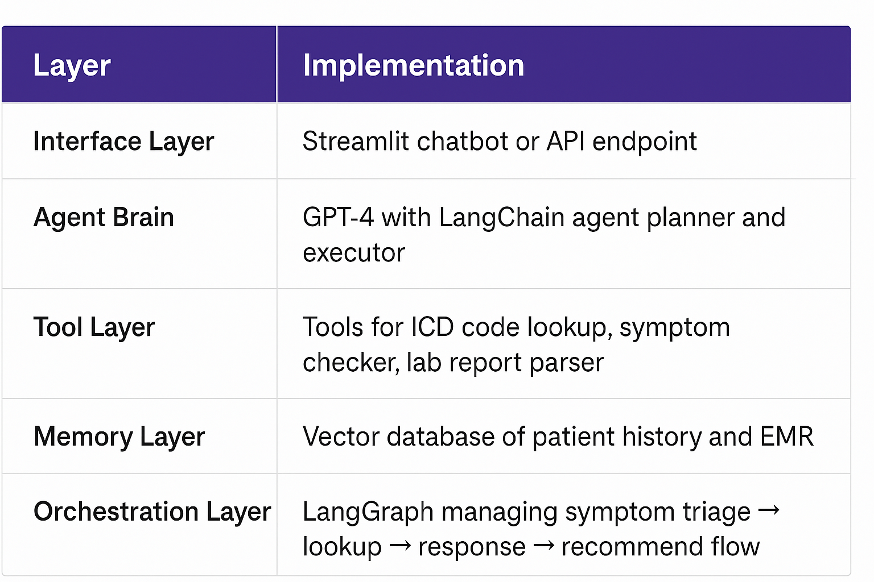

## **🧰 SECTION 5: AGENTIC FRAMEWORKS OVERVIEW**

### **🔗 LangChain – Modular & Simple**

“LangChain is often the **starting point** for building agentic AI applications. Think of it as LEGO blocks for LLMs — it gives you simple, pluggable modules to handle prompting, memory, tool calling, and chaining steps.  
 For example, if I want to create a chatbot that first summarizes an article, then sends an email — LangChain helps me **chain those steps together** using tools like OpenAI and SendGrid.  
 It’s beginner-friendly, modular, and works great for **single-agent, tool-enhanced** workflows.”

### **🔄 LangGraph – State Machine Logic**

“LangGraph builds **on top of LangChain**, but introduces **state machine architecture** — perfect for tasks that require loops, conditional logic, or retries.  
 It’s like drawing a flowchart for your agent and then coding it.  
 Let’s say you want an agent to analyze data, then retry if confidence is low — or ask a human for approval. LangGraph allows that **step-by-step control**.  
 It’s best used for **complex, decision-based flows** where you want clear execution paths.”

### **👥 CrewAI – Multi-Agent Collaboration**

“CrewAI is inspired by the idea that **agents can specialize**, like team members.  
 You define roles — Researcher, Writer, Editor — and CrewAI coordinates the **collaboration between multiple agents**.  
 It’s ideal for workflows like product reviews, RFP responses, or research + summarization — where one LLM shouldn’t do everything alone.  
 This mirrors real-world teamwork and makes agents more **scalable and explainable**.”

### **💬 AutoGen – LLM-to-LLM Interaction**

“AutoGen, from Microsoft, focuses on **structured conversations between LLMs**. It’s like setting up a Slack channel where one LLM asks questions, another answers, and a third verifies.  
 Use cases? Think of AutoGen when you want:

* Agents to debate a solution,
* Validate each other’s reasoning,
* Or perform **self-correction** through dialogue.  
   This shines in research tasks, agent tutoring, or code generation with feedback cycles.”  
  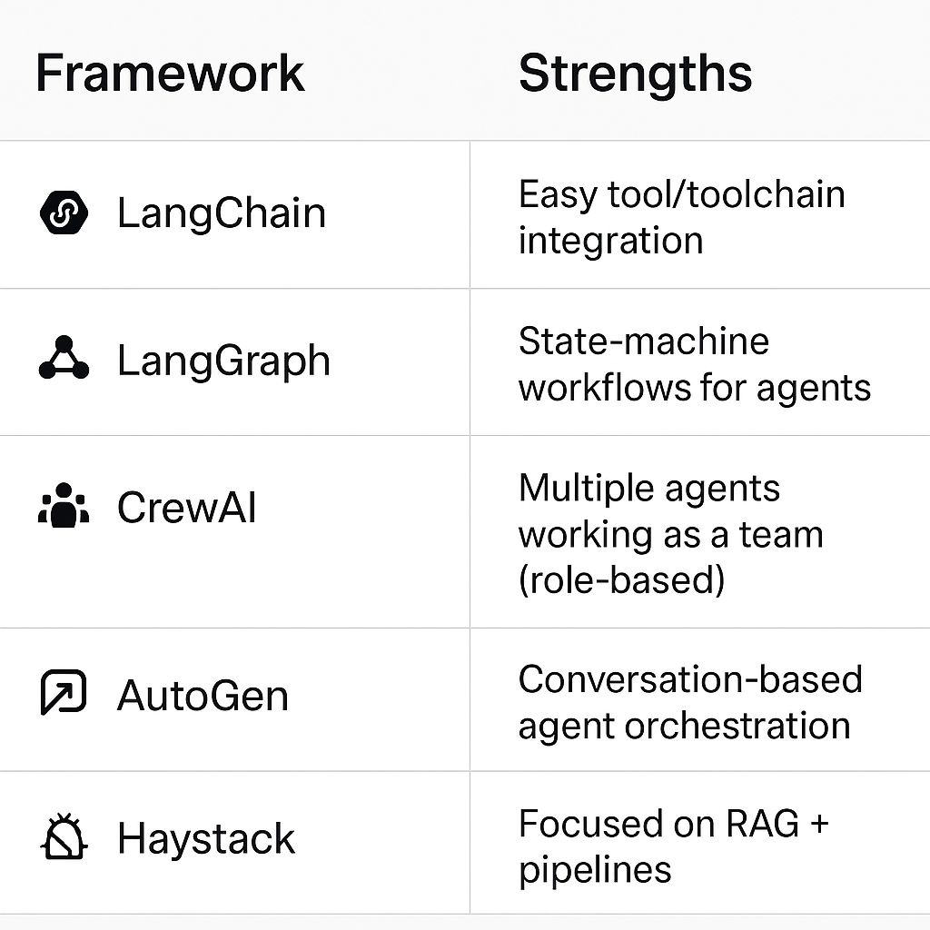

## **⚖️ SECTION 6: AGENTIC vs NON-AGENTIC AI**

| **Feature** | **LLM Chatbot** | **Agentic AI** |
| --- | --- | --- |
| Memory | ❌ Stateless | ✅ Contextual / Episodic |
| External Tools | ❌ Not built-in | ✅ Native support |
| Goal-Oriented Execution | ❌ One-shot | ✅ Multi-step plans |
| Action Automation | ❌ Passive | ✅ Active + Reactive |

## **🧪 SECTION 7: DEMO 1 — Math Tool Agent (Colab)**

### **🔹 What it Does:**

* Takes a question like “Cube of 17 plus 88 divided by 4”
* Uses an external tool (Python eval())
* LLM plans + calculates

### **💡 Tech Stack:**

* LangChain
* OpenAI
* Google Colab
* Python Tools

## **🔥 SECTION 8: DEMO 2 — Research & Summarize Agent (Optional)**

* Use with OpenAI + Wiki
* Searches real-time web content and summarizes
* Emphasize **tool + agent orchestration**

## **📦 SECTION 9: TECH STACK PLACEMENT**

### **👇 Where Agentic AI Fits:**

* **Above the data platform**, **below the UI**
* Connects LLMs to real-world APIs and tools
* Orchestrates pipelines with reasoning

### **🖼️ Visual:**

User Interface (chat / app)

↓

Agentic Orchestrator (LangGraph / CrewAI)

↓

LLM Core (OpenAI, Claude, LLaMA)

↓

Tools (Search, DB, APIs)

↓

Memory (Chroma, Pinecone, Redis)

## **📈 SECTION 10: DESIGNING YOUR OWN AGENT**

### **🛠️ Step-by-Step (Live walkthrough)**

1. Define the **goal**
2. Decide tools needed (search, calc, SQL, etc.)
3. Choose framework (LangChain + LangGraph simplest)
4. Implement and test with verbose logging

## **🚨 SECTION 11: RISKS AND ETHICAL CONSIDERATIONS**

Agentic AI opens up powerful new capabilities—but also introduces new challenges and responsibilities. Below, we break down the core risks, mitigation strategies, and ethical guardrails that every engineering and product team must consider before deploying agentic systems.

### **🤖 1. Hallucinations**

**Issue:** LLMs are probabilistic generators, not fact-retrieval systems. Without grounded information, they can fabricate plausible but false content—especially dangerous in domains like healthcare, finance, or legal.

**Mitigation:**

* Implement **Retrieval-Augmented Generation (RAG)** pipelines to ground responses in trusted documents.
* Use **tool-based agents** to delegate facts to APIs or search tools instead of relying solely on the LLM.
* Add explicit instructions in prompts to "Only summarize from retrieved context."

### **⚠️ 2. Autonomy Gone Wrong**

**Issue:** Autonomous agents can chain actions and invoke tools without constant human input. While this enables automation, it also introduces the risk of agents “running wild” or making unsafe decisions.

**Mitigation:**

* Use **LangGraph** or similar frameworks to define deterministic state transitions, where each step is reviewed or validated.
* Introduce **checkpoints** or **approval steps** in sensitive workflows.
* Set **maximum iteration limits** to prevent infinite loops or runaway behavior.

### **🔐 3. Security Vulnerabilities**

**Issue:** Agents often invoke tools using credentials and environment variables (e.g., API keys). If misconfigured, this can lead to key exposure, unauthorized API calls, or even prompt injection.

**Mitigation:**

* Always use **secure vaults** (like AWS Secrets Manager or .env files with .gitignore) for key storage.
* Restrict LLM access to only safe tools and avoid dynamic tool loading unless strictly needed.
* Sanitize and validate all inputs—**especially user inputs**—to avoid prompt injection.

### **⚖️ 4. Bias and Fairness**

**Issue:** LLMs can encode and reproduce societal or data-driven biases (e.g., racial, gender, geographic). When used in decision-making agents (e.g., hiring, admissions), this can perpetuate discrimination.

**Mitigation:**

* Audit agent outputs across demographic slices using fairness evaluation tools.
* Prefer LLMs fine-tuned on **diverse, representative datasets**.
* Implement **transparent reasoning chains** or explainability methods (e.g., Chain-of-Thought) to make decisions auditable.
* Include fairness criteria in your acceptance tests.

### **🧑‍⚖️ 5. Over-Reliance or Over-Delegation**

**Issue:** As agents become more competent, there’s a growing temptation to automate high-stakes decisions—without oversight.

**Risks:**

* An AI recommending a **treatment plan** without a doctor.
* A sales agent negotiating discounts **without policy compliance**.
* A customer support agent issuing **full refunds unsupervised**.

**Mitigation:**

* Implement **Human-in-the-Loop (HITL)** approval steps for high-impact actions.
* Define clear **task boundaries**: Which tasks are fully autonomous vs. which require human review.
* Regularly review **agent decisions and logs** for anomalies or unacceptable actions.

### **🛡️ 6. Guardrails and Controls**

**Think of guardrails like bowling bumpers—agents should be powerful but safe.**

**Examples of Guardrails:**

* **Tool Whitelisting:** Only allow predefined APIs/tools to be used.
* **Role-Based Permissions:** Limit actions based on who initiated the agent (admin vs. analyst).
* **Workflow Constraints:** For example, “Agent can suggest a treatment plan, but cannot submit it to EMR without physician sign-off.”
* **Rate limiting** and **usage quotas** to prevent runaway cost or misuse.

### **💰 7. Latency & Cost Tradeoffs**

**Issue:** Each agentic step (e.g., search, summarization, chaining, tool use) costs tokens and time.

**Example:** An agent performing 5 steps—querying a knowledge base, searching the web, summarizing, reasoning, and writing—may cost **10x more tokens** and several seconds more latency than a single-chatbot answer.

**Mitigation:**

* Design for **efficiency**: Prioritize high-impact chains, and batch where possible.
* Add **fallback logic**: If no context is found, return a default answer rather than keep looping.
* Monitor **token usage** with analytics.

### **🧪 8. Testing, Simulation, and Evaluation**

**Issue:** Most real-world failures stem not from architecture—but from lack of simulation and validation.

**Mitigation:**

* Use **unit tests** for each agent step.
* Simulate end-to-end workflows with edge-case scenarios.
* Evaluate outputs with a mix of **automated tests + human reviewers.**
* Track metrics like: accuracy, hallucination rate, task success, and latency.  
  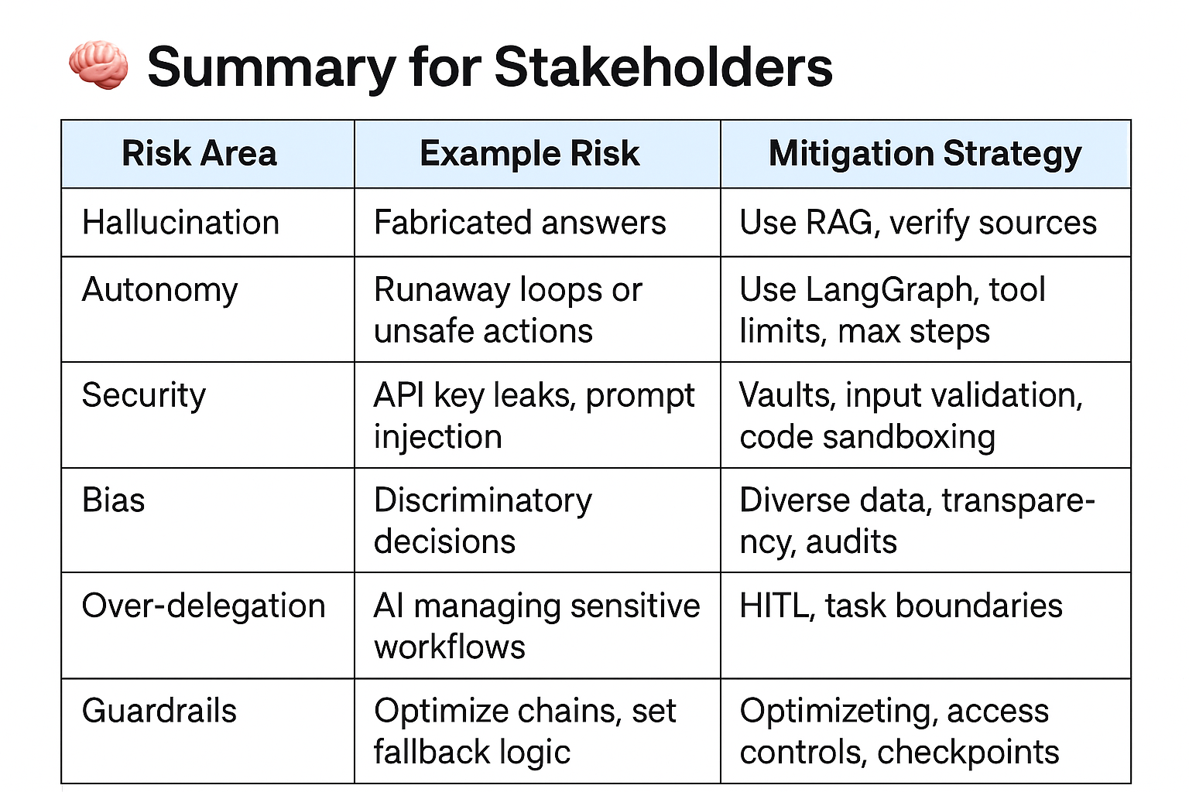

## **🔮 SECTION 12: THE FUTURE OF AGENTIC AI**

* **Personal Assistants**
* **Team agents** (marketing agents, ops agents, finance agents)
* **Hybrid apps**: low-code + LLMs + agents
* **Enterprise orchestration**: plug-and-play AI workflows

## **✅ FINAL WRAP-UP & Q&A**

### **Suggested Prompt:**

“What’s one area in your current workflow where an AI agent could save you time or automate a repetitive task?”